Freestyle 411

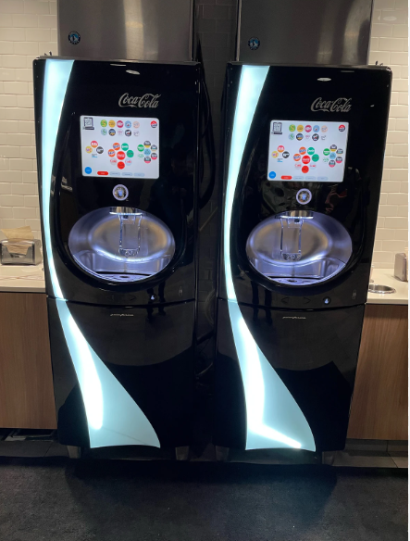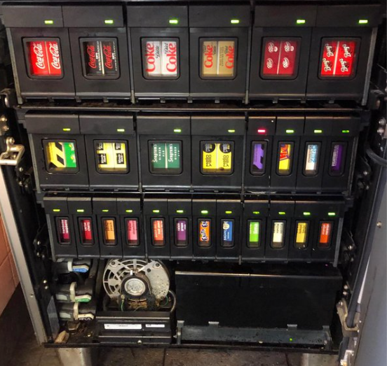
Getting to know the machines…
How do you get into the machine?
How do you identify when to change syrup,NNS,HFCS?
How to tell where a cartridge should be placed.
Where is the back up stock? How do we change them?
What is priming?
Why do we lock the machines? How?
How to unlock?



Nightly Cleaning Process
1)Check to make sure there are no products that need to be replaced on dashboard
2)Removed the parts for the ice dispenser and bottom steel pan and run through the dish pit on flat rack.
3)Remove the main nozzle and let it soak in sanitizer as you clean the machine and parts.
4)Use red bristle brush to scrub the area around where the syrup is dispensed with sanitizer.
5)Wipe out inner steel walls and black drain area below with Multisurface.
6)Use Kettle to pour hot water down the drain area of each machine
7)Replace all clean parts
8)Wipe down outside of machine with multisurface-top to bottom.

Deep Clean on Sunday/Monday Process
On Sunday night…1)Unplug the ice machine on designated machine.
2)Remove cartridges 1 shelf at a time into a clean bus tub
3)Wash the plastic holders for the cartridges in the dish pit as you remove them
3)Wipe down each shelf with sanitizer. Make sure to get top, all the way back and the male piece that fits into the cartridges.
4)After a shelf is clean and holders are washed replace the cartridges on each shelf and continue working down the machine.
5)When all cartridges and shelves are clean and product replaced wipe inside of lower door, NNS box and any area we can get to next to NNS box.
6)Pull latch at bottom left corner of the top door to release and open. We will now clean any surfaces inside the top portion of machine including the top door.
7)Ready to close up the machine. Always close the TOP DOOR first then lower door.
8)Open the control panel and prime all ingredients.

Monday…1)Check to see if ice has cleared from bin by unlocking latches on the top door to the ice bin. Run the top door through dish to remove any dust.
2)Clear any remaining ice
3)Wipe out inside of bin with sanitizer. Make sure to get around the edges and in any creases.
4)Run clean sanitizer through the bin to clear any debris that may have been left from cleaning.
5)Replace ice from back ice machine
6)Replace the lid from the dish pit to the ice bin.
7) Plug the top ice maker back in.
8)Wipe Freestyle machine down top to bottom using Sanitizer on areas where product will touch and be consumed and the multisurface for the outer surfaces.
9)Polish outside of the ice maker with Medallion a stainless steel cleaner.
10)Wipe down counters around machine.

