**COFFEE-TREE AGUAMILPA (PLAZA CANTERA)**

**FRENTE**

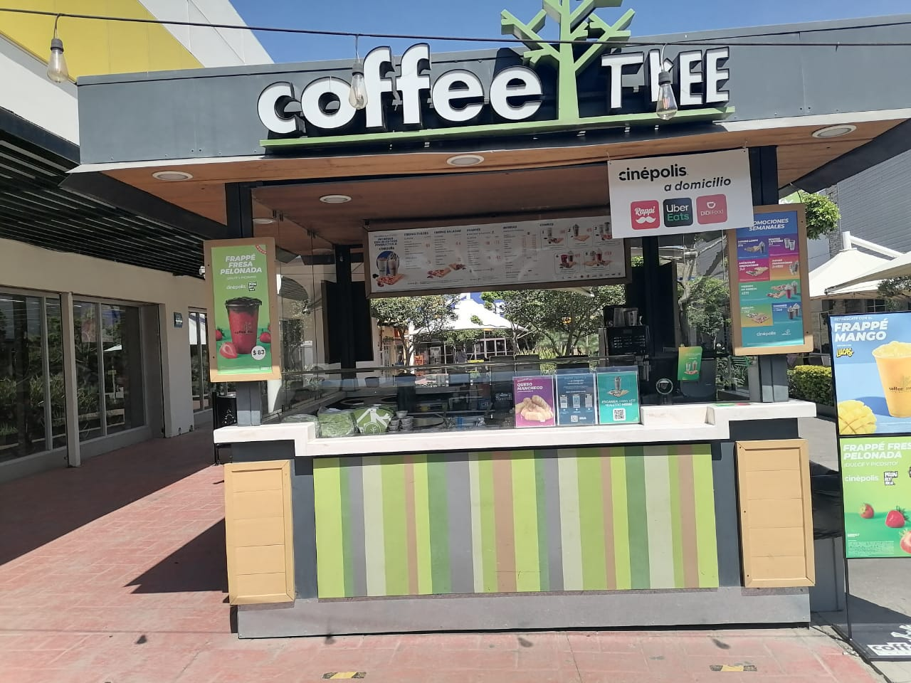

**LADOS LATERALES**

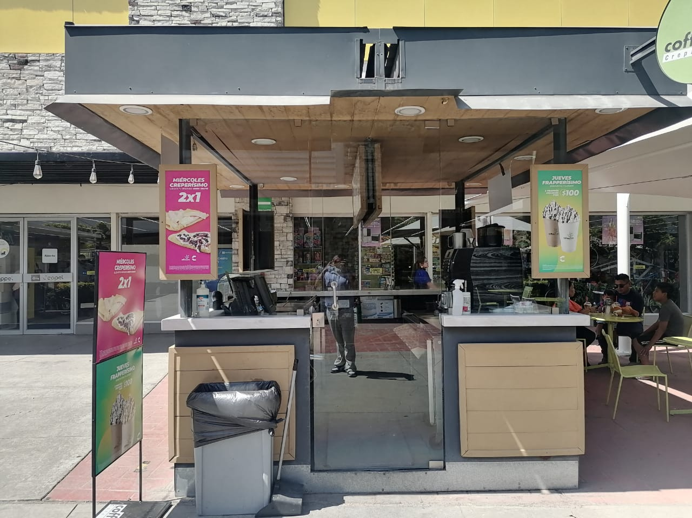

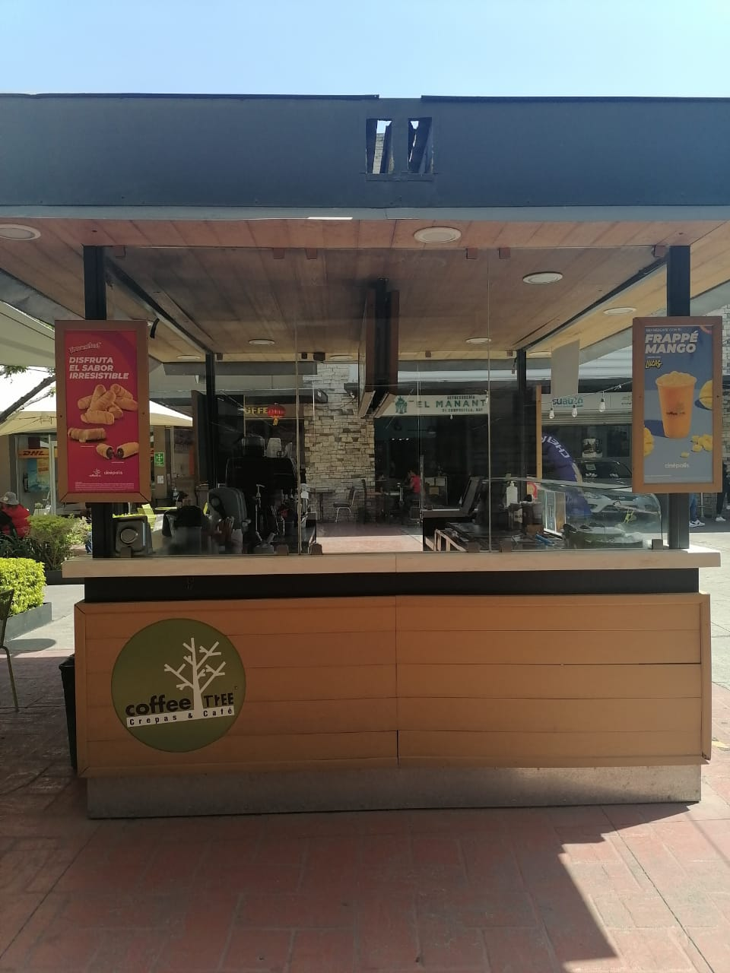

**PARTE TRASERA**

